Long-term follow up of high-risk lesions (B3-Llsions) with no surgical resection
Update from the MIBB Database

Aim
Purpose of this study was to analyze the long-term outcome of patients who received the diagnosis of high-risk lesions (B3 lesions) at imaging-guided vacuum biopsy. Upgrade rates of high-lesions to malignant lesions and the detection of new malignancies or high-risk lesions during follow was determined. Aim was to prove whether follow-up of high-risk lesions is a save management approach with an acceptable upgrade-rate during follow up and an alternative to surgical resection of high-risk lesions. Long-term goal is to adapt current national (and international) management guidelines of high-risk lesions based on our results.
Secondary aim is to identify special patient-groups or special lesions groups of high-risk lesions who benefit most from follow up instead of excision. Here aim is to define patient groups or lesion groups in that surgical excision is still recommended due to an inacceptable high upgrade-rate during follow up.
Material and Methods
As part of the Society of minimal invasive breast biopsy (MIBB) in Switzerland a systematic database of all performed breast biopsies in Switzerland was established. Based on our and international initial experiences on the benefit of high-risk lesions follow-up instead of open surgery, follow-up was performed increasingly common at many Swiss breast centers in women with the diagnosis of high-risk lesions during the last years.
Data from 378 women with the diagnosis of high-risk lesions were entered in the MIBB-database. 278 patients with 286 high-lesions were included in the final study analysis, after exclusion of women who did not met the inclusion criteria. All patients underwent a follow-up either with performing breast imaging or with a personal interview. More than 85% of all study participants underwent a follow-up time interval of at least 3 years with a mean follow-up interval among of women of 58.9 / 24.3 months (about 5 years).
The following data were analyzed: Demographic data, type of high-risk lesion at biopsy, time interval of follow up at (> 12 months), reason for not performing open surgery, event during follow up (high-risk lesion or malignancy at biopsy site or other breast region) and histological details of the initial high-risk lesion and the histology of any occurred pathologic lesion during follow up.
Results
The 278 study patients showed demographic and clinical characteristics, which were representative for patients seen in most of the Swiss breast cancer in clinical routine. So, patients were mainly postmenopausal, at average risk with an mean age of 53.5 / ±10.7 years at the time of initial diagnosis of high-risk lesions. Distribution of histological diagnosis were also equivalent with the distribution of the high-risk lesions in clinical practice, with ADH, FEA and LIN being the most frequent B3-lesions.
Among all study patients 15% (44/286) developed a relevant breast lesions during follow-up. Of those 57% (25/44) were B3 lesions and the remaining 43% (16/44) were malignant lesions (36% invasive cancers and 7% DCIS). Which were 8.7% (25/286) high-risk lesions and 6.6% (19/286) malignant lesions in relation of all included lesions.

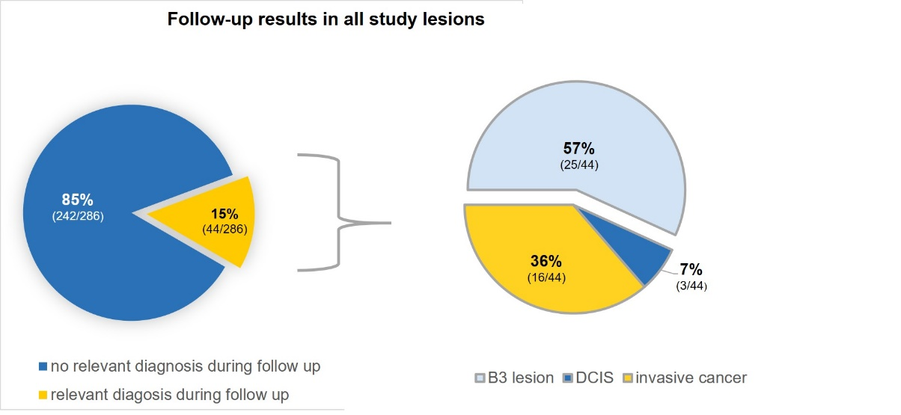

Malignant lesions were in the majority minimal cancers (62%).
High-risk lesions or malignant lesions occurred in the vast majority of women after 5 years with a mean time interval of 67 months.
The lesions with the highest upgrade rate during follow-up was ADH with an upgrading in 28% (7/25) lesions. Besides these patients with initial ADHs, no patient or lesions groups could be identified in whom / which follow-up instead of surgical resection resulted in an unacceptable high upgrade rate during follow up.

Conclusion and outlook
- Follow up is an acceptable management of high-risk lesions. Only in ADH a resection should be considered, due to the higher malignancy rate during follow up.
- Need for long-term follow up, as most events occurred > 5 years after initial B3 diagnosis.
- With intensified diagnostic follow up concept, detection of follow up events in small cancer stages (minimal cancer) is possible in the majority of patients.

- Additional study for direct comparison of women with high-risk lesions who underwent follow-up with those who underwent surgical resection. Evaluation of matched patients from the MIBB database.

- Multicentric study.

- New consensus conference.

